Project Initialization and Planning Phase

Team ID | MCA
Project Name | Online Education Analytics Dashboard – Student Performance, Engagement & Dropout Analysis
Maximum Marks | 3 Marks

Define Problem Statements (Problem Statement Template):

Create a problem statement to understand the point of view of the people who use the Online Education Analytics Dashboard. This template helps the team focus on what matters: identifying students who are at risk of dropping out, understanding how engagement affects scores and final results, and deciding where support is needed. A well-articulated problem statement helps us find the right solution for programme administrators, course instructors and student support planners, and understand how they experience the problem.
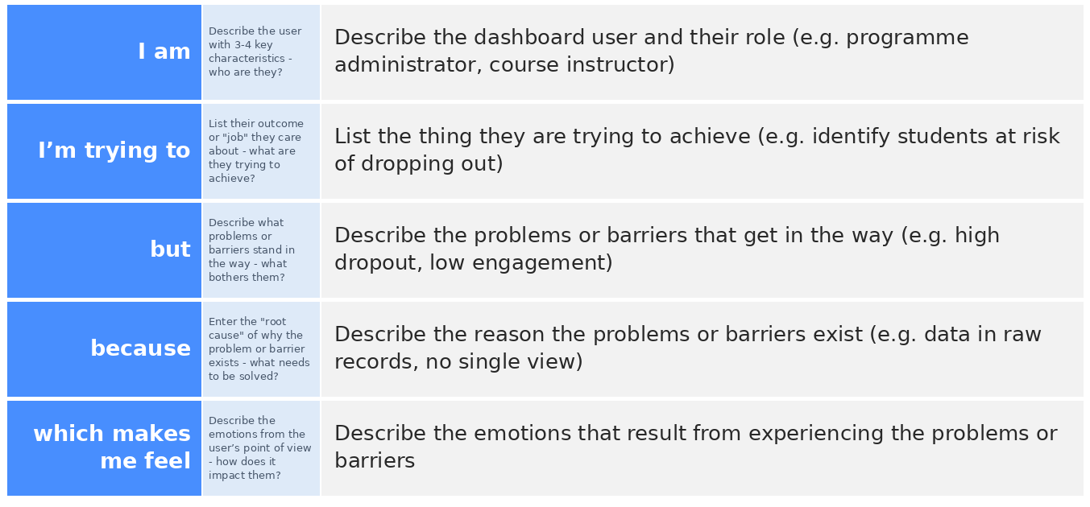
Reference: https://github.com/paricharlasaiteja014-wq/Online-Learning-Engagement-and-Student-Performance-Analysis
Example:


Problem  Statement (PS) | I am  (User) | I’m trying to | But | Because | Which makes me feel
PS-1 | An online-learning programme administrator | identify which students are at risk of dropping out so I can support them early | about 1 in 4 learners drop out (dropout rate 0.26) and over half are rated High or Very High Risk | engagement, prior education and results sit in raw student records with no single view of the risk factors | Worried and unable to act early
PS-2 | A course instructor | understand how student engagement affects scores and final results | activity is very uneven (High engagement averages 3.7K clicks vs 0.2K for Low) and I cannot see who is falling behind | click counts and scores are hard to interpret without grouped, filterable views by engagement and performance level | Uncertain and unable to intervene in time
PS-3 | A student support / policy planner | decide where to focus support across education backgrounds and regions | dropout ranges from 0.373 (no formal qualifications) to 0.219 (post graduate), while scores barely differ by region | there is no side-by-side comparison of student groups against dropout, pass rate and score | Unsure where to invest limited resources

